arduino programming for MacOS

Step1: Download the Arduino Software (IDE)

·Open the URL:<https://www.arduino.cc/en/Main/Software> with browser

·Click Mac OSX 10.7 Lion or newer

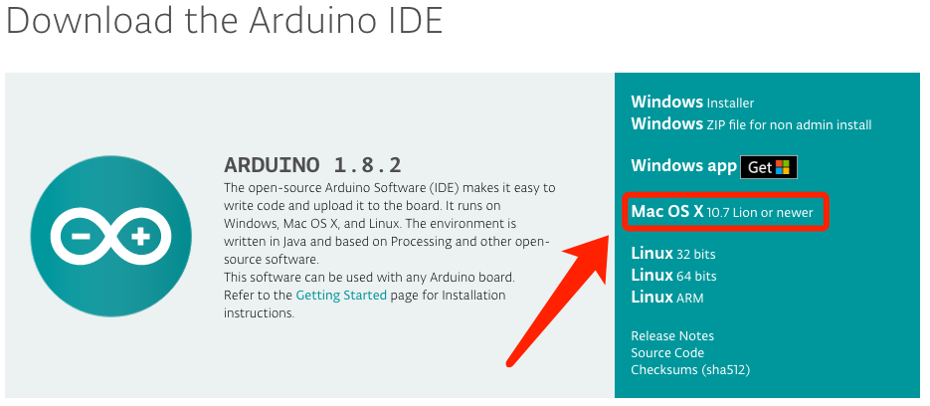

·Click JUST DOWNLOAD

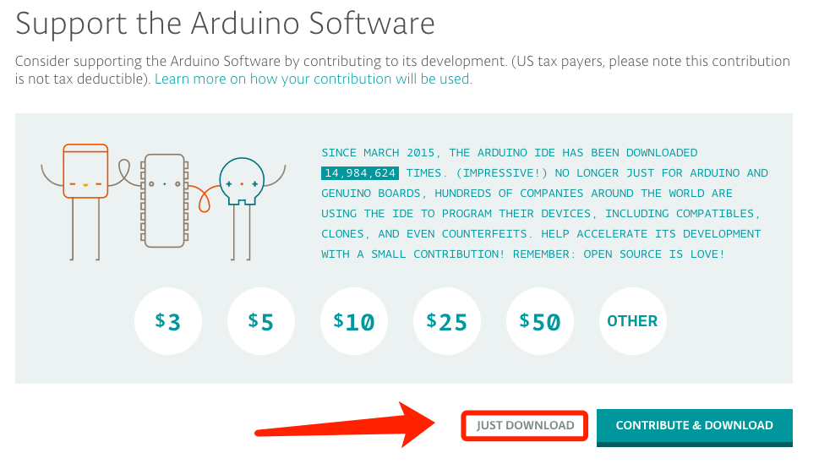

·Open Finder

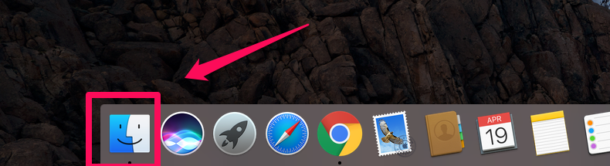

·The download file is arduino-1.8.2.-macosx.zip

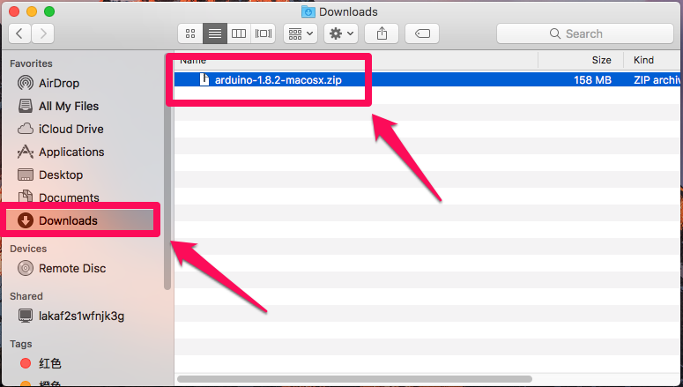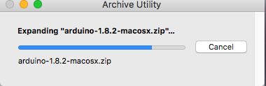

·Double click arduino-1.8.2.-macosx.zip to upzip the arduino file

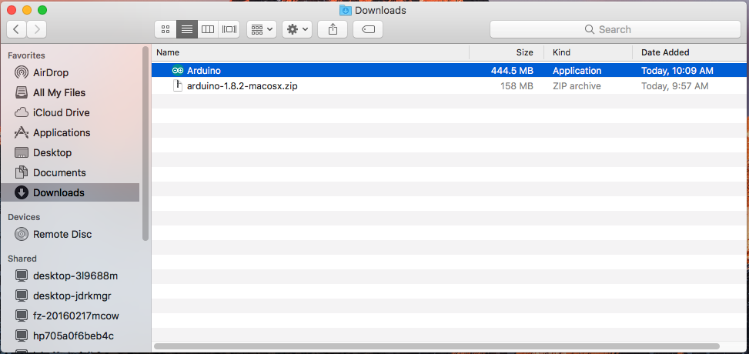

·arduino file is the Arduino application, just double click to open it

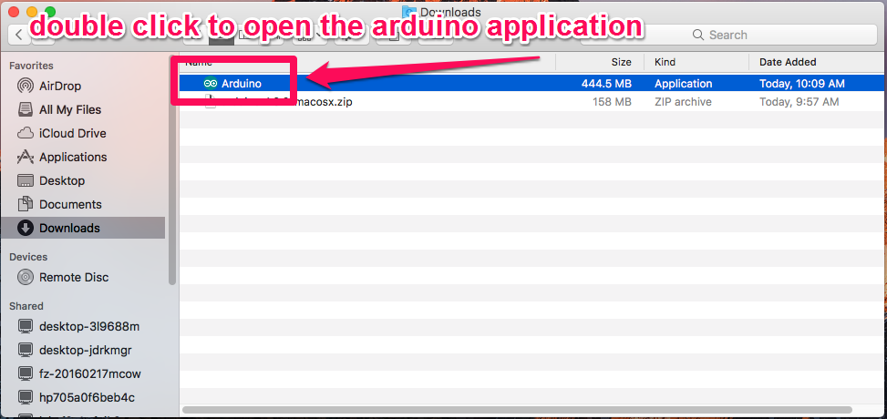

·Arduino IDE

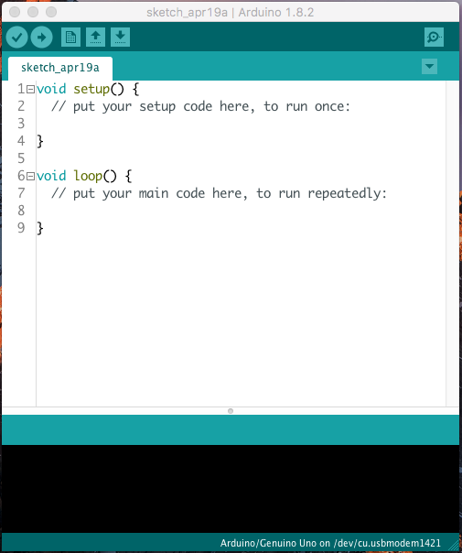

·Connect UNO to PC with USB and remove the Bluetooth module.

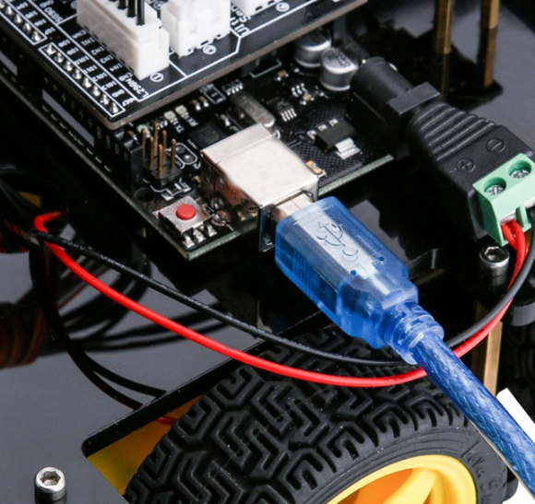

·Select UNO board

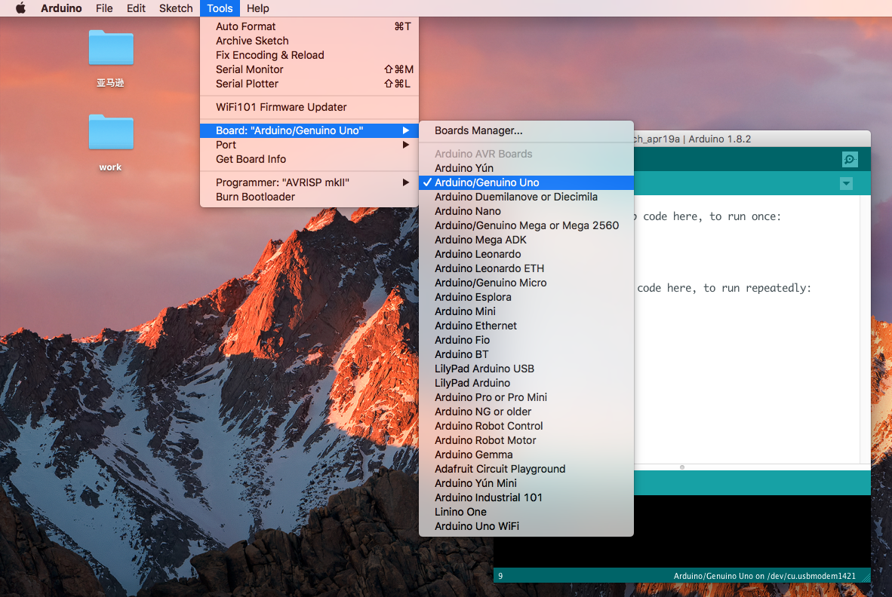

·Select port name

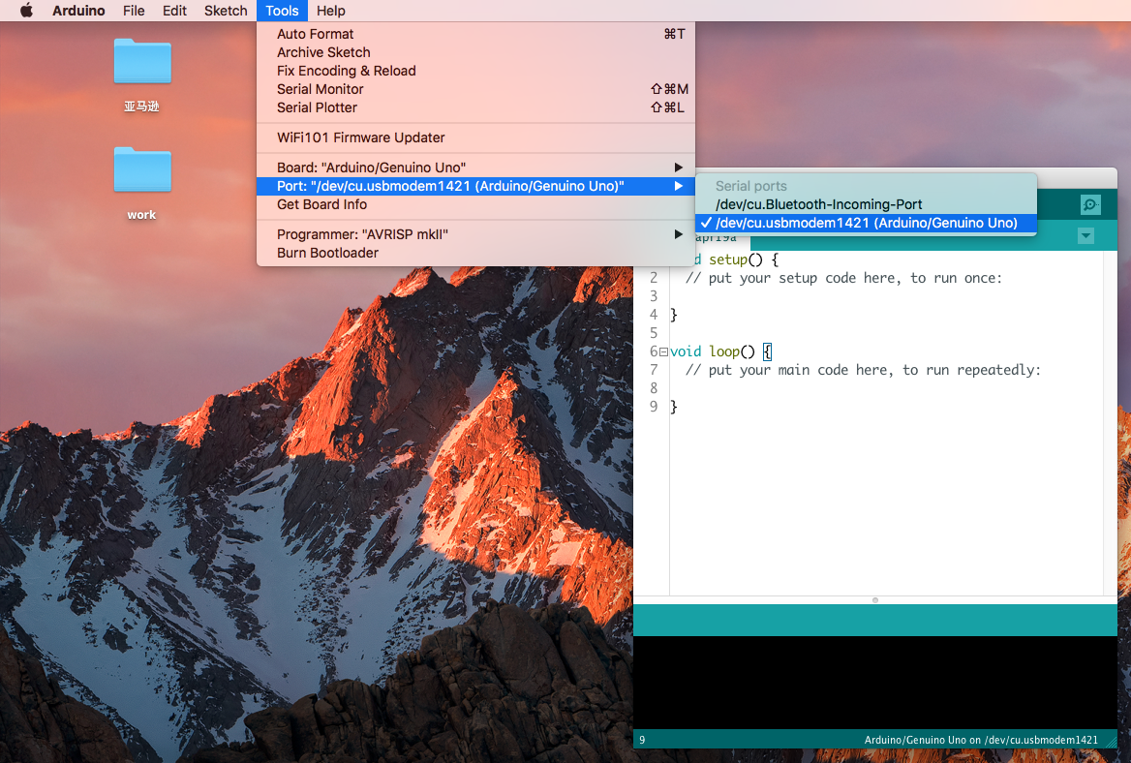

***\*Attention: The port name does not have to be the exact name on the screenshot above, but you will surely find a port for the UNO.***

·Open a program AUTO_GO_.ino to test the Arduino software

The code in the directory: /Elegoo Smart Robot Car Kit/Lesson 1 Make The Car Move/AUTO_GO_/AUTO_GO_.ino

Double click AUTO_GO_.ino

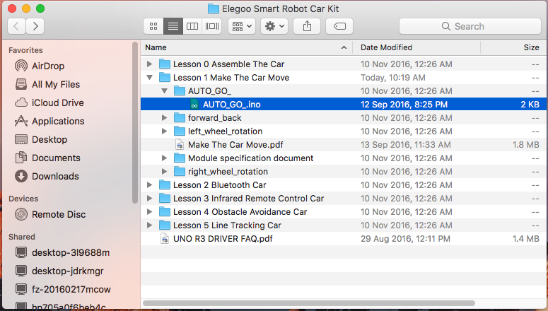

·After open the code

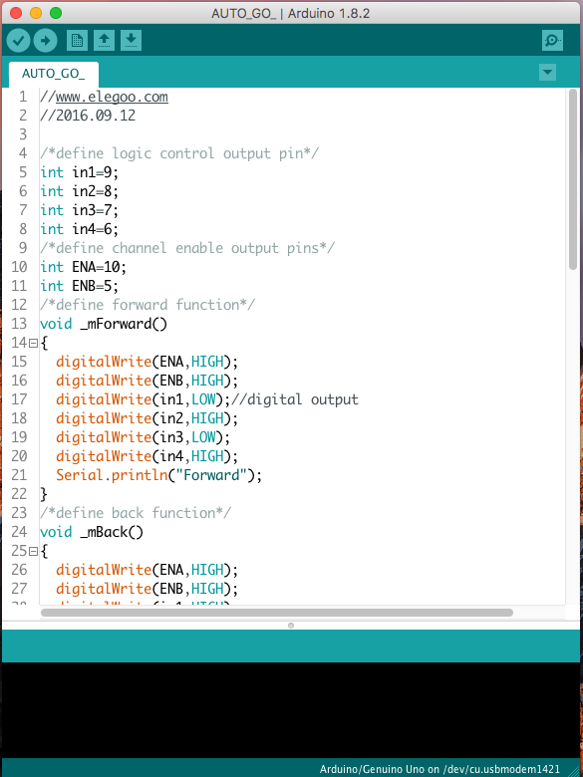

·Click the hook button to verify the code

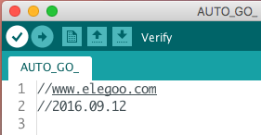

·Click the arrow button to upload the code

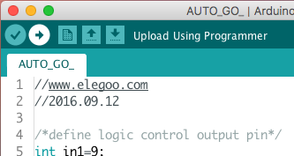

·Done uplaoding

